

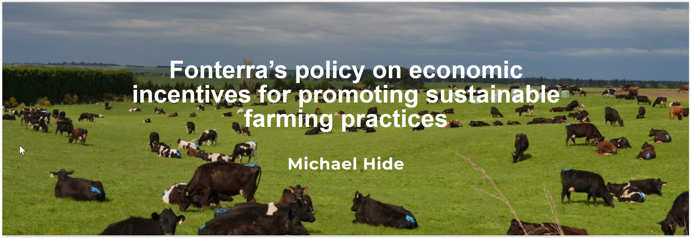

**Brief description of the policy**

For the 2021/2022 season, Fonterra rolled out a new payment parameter designed to link a portion of the Milk Price to the performance of individual farmers under the voluntary ‘The Co-operative Difference’ framework. Under this framework, a maximum 10 cents per kilogram of milk solids (kgMS) incentive payment was approved by the Fonterra Board for the 2021/2022 season (this value will subsequently be reviewed annually). The scheme is funded through a re-allocation of the Milk Price. Therefore, the more farmers who achieve under the scheme, the lower the overall Base Milk Price becomes to compensate. The Co-operative Difference framework itself comprises  three distinct sequential levels of achievement: Te Pūtake, Te Puku and Te Tihi.

The first level, Te Pūtake, represents Fonterra’s strong and sustainable base which is of critical importance when it comes to embodying Fonterra’s strategy focus around creating sustainable value. In order to achieve Te Pūtake, farmers must achieve a number of requirements under four focus areas: ‘Co-op and Prosperity’, ‘Environment’, ’Animals’ and ‘People and Community’. All farms that meet the requirements for Te Pūtake receive 7c/kgMS and are eligible to achieve the next level, Te Puku.

Te Puku is where Fonterra recognises milk quality excellence. Our farmer shareholders told us they wanted a milk quality framework that was flexible, motivational and fair. In order to deliver this, an entirely new Milk Quality Framework was developed to replace our existing demerit and grading system. Under this new framework, if a farm achieves 30 days with a milk quality rating of ‘Excellence’ during the season, they receive an additional 3c/kg MS for all milk supplied with an ‘Excellence’ rating during the season.

The final achievement level, Te Tihi, represents the pinnacle and is an opportunity for us to recognise the leading farmers in the Co-operative. In order to achieve Te Tihi, a farm must meet the two prior levels of achievement and must maintain a Milk Quality Excellence rating for at least 90% of their milk supplied. Unlike the previous levels, there is no direct financial incentive, rather, Te Tihi is all about recognition. As such, farms that achieve Te Tihi receive recognition in the Annual Report, at annual awards events and they also receive Te Tihi branded merchandise and products.

**Catalysts for the development and implementation of the policy and supporting science**

Ongoing consumer insight research into our key markets consistently highlights a growing demand for waste minimisation, pasture-based production, animal welfare/quality of life and minimum expectations regarding working conditions for employees on farm. It’s becoming more and more evident that the environment in which we operate is perpetually in a state of change; shifts in customer and community expectations, regulations and market requirements can all make change challenging and time consuming.

At times, New Zealand sourced Fonterra products sell at a premium. While it is not always possible to highlight exactly why this is the case, the Co-operative’s reputation for pasture based, low carbon dairy is likely a major contributing factor. Considering this, in conjunction with regulatory, social and environmental changes, one can reasonably assume that pro-active management of on farm issues is a good foundation for resilient, sustainable and profitable farming. Conversely, a lack of resilience within the farming businesses that supply the Co-operative represents a critical risk for Fonterra itself. Therefore, in order to support the achievement of our strategic goals, add value to our farmers and position Fonterra as the milk supply company of choice for the New Zealand market, the conclusion was reached that the Co-operative had to move beyond relying solely on minimum standards. As a direct response, The Co-operative Difference was launched in 2019 following extensive feedback from farmers in relation to how they would like to see the Co-operative manage issues around on-farm practices that are likely to impact the Co-operative both now and in the future. After all, our ability to generate value and meet our strategic objectives is largely reliant on our farmers being able to produce high quality, sustainable dairy products that are ahead of increasingly ambitious customer, consumer and stakeholder expectations.

**The expected impacts of the policy and actual impacts so far observed**

At its core, The Co-operative Difference payment is designed to reinforce the importance of change and encourage early adoption of on-farm practices deemed important to support the achievement of our strategy. We want to recognise and reward our leading farmers who already contribute significant value to the Co-operative by going above and beyond while concurrently incentivising other farms to continuously improve their on-farm performance in a number of key areas. Put simply - more ‘carrot’, less ‘stick’. While the stick can be effective, it often comes at the expense of farmer engagement and is more likely to result in minimum compliance, rather than positive and ongoing change.

A healthy, thriving environment is the foundation of a healthy, thriving farm. Through the environment related achievements in The Co-operative Difference, we are focused on being the most emissions efficient and environmentally sustainable dairy provider by reducing our on-farm footprint and working with the environment. We believe healthy freshwater, soil, ecosystems and a stable climate are essential to the long-term success of dairy farming in New Zealand. In the past 10 years, our farmers have invested heavily in environmental protection, installing new effluent systems and fencing 98% of significant waterways. Under The Co-operative Difference, we are taking this a step further; in order to meet the requirements for the ‘Environment’ achievement for the 2022-2023 season, farms needed a Farm Environment Plan in place in addition to three out of the five following sub-achievements: having a Purchased Nitrogen Surplus below a target level, participate in a product stewardship scheme for on farm plastics and agri-chemicals, have a winter management plan, have no discharge of effluent to water and/or utilise at least 80% of pasture-based feed across the season.

The welfare of our dairy cows is also of paramount importance. We care for our animals and want them to have healthy disease-free lives. Furthermore, our customers, consumers and fellow New Zealanders expect our animals to be healthy and treated with the care and respect they deserve. To help strengthen the relationship between veterinarians and our farmers to improve animal welfare outcomes, The Co-operative Difference ‘Animals’ achievement for the 2022-2023 season requires farms to have a current Animal Wellbeing Plan, developed with a registered veterinarian, covering: Body Condition Scoring, mastitis, lameness, mortality, antimicrobial resistance, planning for extreme weather events, polled genetics and management strategies for heat stress. We hope this will lead to a significant improvement in relation to risk identification and mitigation of common animal welfare related issues on farm.

Healthy people is one of the three overarching goals set out in the Fonterra strategy. As an industry, dairy is facing challenges in attracting and retaining talent; this along with agriculture’s relatively poor track record in regards to health and safety means there is work to do in this space. Furthermore, many of our major customers have minimum expectations about the way that employees are treated on farm. In order to help improve practices and the dairy industry’s reputation as a source of employment, The Co-operative Difference ‘People and Community’ achievement, requires all participating farms to complete the DairyNZ Workplace 360 assessment and achieve 100% on the first of three sections. At the end of the day, empowering people to create goodness for generations is at the core of our Co-op. Workers should be able to work in safe and healthy work environments so they can thrive at work and get home safe every day.

Milk quality is a key driver for Fonterra in many ways as it can impact the flavour, yields, shelf-life and functionality of end products. Our strong reputation for producing high quality products can largely be attributed to the high-quality milk supplied by Fonterra farmers. In recent years, the Co-operative as a whole has made significant progress towards improving the quality of the bulk milk supply. Today, at a global level, Fonterra’s milk quality is firmly in the leading pack and our reputation for quality is strong. However, there still remains significant variation in quality across the supply base; if the average milk quality across the Co-operative was the same as our lowest 10%, it would likely cause significant issues including product quality issues, non-conformance with Overseas Market Access Requirements and increases in the cost of quality failure. Previously, all farms that provided milk that met the quality parameters defined in the Terms of Supply were paid the same regardless of the level of quality provided. By providing a financial incentive related to milk quality, The Co-operative Difference achievement seeks to recognise and reward those farms who provide above average milk quality while concurrently encouraging all farmer to improve their performance and meet expectations. We’re confident that this will drive continued improvements to milk quality into the future.

**Some reflections on the policy implementation and the way forward**

The uptake, awareness and engagement we have seen in this inaugural season of The Co-operative Difference payment has surpassed our expectations with over 6000 farms achieving at least Te Pūtake in the 2021/2022 season. The Farm Source division now sees The Co-operative Difference as central to their engagement with Fonterra’s farmer base.  This is a very encouraging start in relation to ensuring that farmers have the opportunity to adapt to changes at a pace that works for them and their businesses. As time goes on and the levels of achievement across the farmer base improve, the requirements and payments will also likely change and evolve, thereby continuing the incremental improvements to the standard of farming and ultimately create sustainable value for generations to come.